Roshan Jaiswal-Ferri 1
Workspace Prep 1
Plotting for part c 1
Determine the spring constant and effective mass from Period vs. Mass 2
Finding Period of phone on spring 4

Roshan Jaiswal-Ferri
%Section - 45
%PHYS 142

Workspace Prep
warning off
format long %Allows for more accurate decimals
close all; %Clears all
clear all; %Clears Workspace
clc; %Clears Command Window

Plotting for part c
lp = [110, 2.31;
80, 2.13;
70, 1.72;
58, 1.58;
36, 1.48;
30, 1.39;
10, 1.32];
x = (lp(:,1)/100)';
T2 = lp(:,2).^2;
p = polyfit(x,T2,1);
bf = polyval(p,x);
g = (4*pi^2)/p(1);
figure('Name','Linearized Form')
plot(x,T2,'*')
hold on
grid on
plot(x,bf)
plot(0,0,'r.')
plot(0,0,'r*')
plot(0,0,'ro')
xlabel('String Length (m)')
ylabel('Period T^2 (s^2)')
title('Linearized Form')
legend('Data Points','Line of Best Fit (y = 3.8236x + 0.875) ',...
'Origin',Location='best')
disp(['Calculated g: ', num2str(g), 'm/s^2'])
disp(['Percent Dif.: ', num2str(abs((9.80-g)/9.80)*100), '%'])
disp(' ')
Calculated g: 10.3248m/s^2
Percent Dif.: 5.3554%
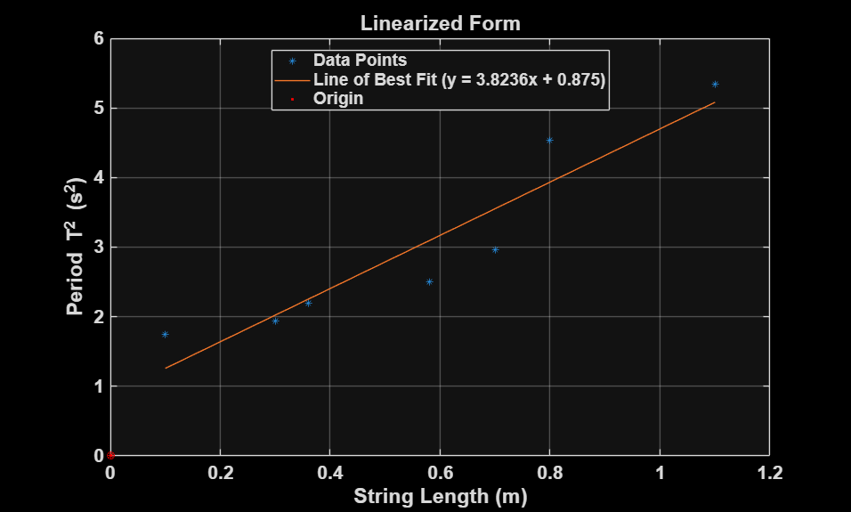

Determine the spring constant and effective mass from Period vs. Mass
msp = 0.162;
g = 9.81;
mass = [96.4, 146.4, 196.4, 246.4, 296.4, 346.4, 396.4]./1000; %in kg
period = [0.883, 0.966, 1.22, 1.21, 1.24, 1.32, 1.6]; %seconds
force = mass.*g; %force in newtons
k = (4*pi^2.*mass)./period.^2;
k = mean(k);
meff = (1/3)*msp; %apprax mass fraction
disp(['K value found from mass & period: ', num2str(k), ' N-m'])
disp(['Effective mass fraction of spring: ', num2str(meff), ' kg'])
Tsp2 = period.^2;
k = 8.44;
beta = 1/3;
p2 = polyfit(mass,Tsp2,1);
bf2 = polyval(p2,mass); %line of best fit
meffsp = (p2(2)*k)/(4*pi^2*beta);
disp(['Effective mass fraction of spring calculated: ',...
num2str(meffsp), ' kg'])
figure('Name','Linearized Form Spring Constant')
plot(mass,Tsp2,'*')
hold on
grid on
plot(mass,bf2)
plot(0,0,'r.')
plot(0,0,'r*')
plot(0,0,'ro')
xlabel('Attatched Mass (kg)')
ylabel('Period T^2 (s^2)')
title('Linearized Form Spring Constant')
legend('Data Points','Line of Best Fit (y = 5.0062x + 0.2672) ',...
'Origin',Location='best')
K value found from mass & period: 6.3571 N-m
Effective mass fraction of spring: 0.054 kg
Effective mass fraction of spring calculated: 0.1714 kg
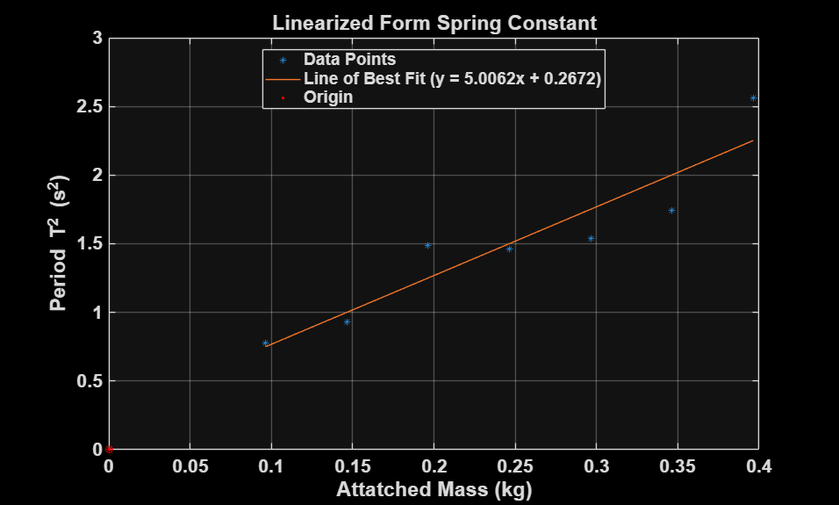

Finding Period of phone on spring
data = readtable('Acceleration without g 2025-04-09 13-13-45.xls');
t2 = data.Time_s_;
a2 = data.LinearAccelerationY_m_s_2_;
t = t2(1:200);
a = a2(1:200);
zero_crossings = []; % to store interpolated time values at zero crossing
for i = 1:length(a)-1
if a(i) * a(i+1) < 0 % sign change => zero crossing
% Linear interpolation to estimate crossing time
t0 = t(i);
t1 = t(i+1);
a0 = a(i);
a1 = a(i+1);
% Interpolate to find zero crossing time
t_cross = t0 - a0 * (t1 - t0) / (a1 - a0);
zero_crossings(end+1) = t_cross;
end
end
disp('Zero crossings occur at times:');
disp(num2str(zero_crossings));
t1 = mean(zero_crossings(1:3));
t2 = mean(zero_crossings(4:6));
dt = t2-t1;
p = dt*2;
disp(['period: ', num2str(p)])
% figure('Name','Gathered Data')
% plot(t,a)
% xlabel('Time (s)')
% ylabel('Accel (g)')
% grid on
Zero crossings occur at times:
0.33242 0.3482 0.35676 0.91322 0.93087 0.94989 1.4988
period: 1.1711
Published with MATLAB® R2024b

